**BIOGRAPHICAL DATA**

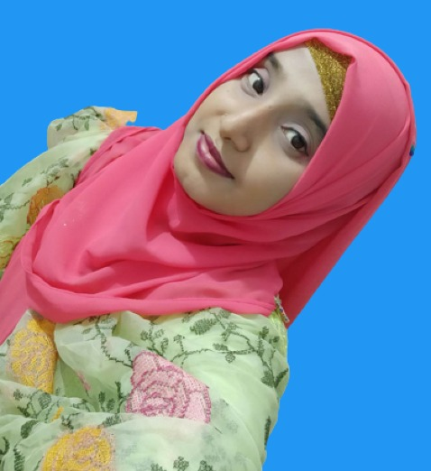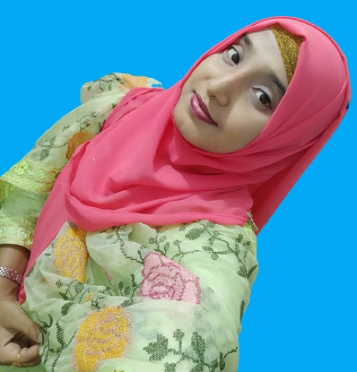

**Shirajum Monira**

Master of Science 1st Year

Department of Economics

Hajee Mohammad Danesh Science and Technology, Dinajpur

Contact no: 01723-695251 (Brother)

**EDUCATIONAL QUALIFICATION**

**Master of Science in Economics**

University/College : Hajee Mohammad Danesh Science and Technology, Dinajpur

Passing Year : 1st year student

**B.S.S Hons in Economics**

University/College : Hajee Mohammad Danesh Science and Technology, Dinajpur

Passing Year : 2022

Result : CGPA 3.62 Out of 4.00

**Higher Secondary Certificate**

Institute : Jafarpara Darul Ulum Kamil Madrasah, Pirganj, Rangpur

Passing Year : 2017

Result : CGPA 4.79 Out of 5.00

**Secondary School Certificate**

Institute : Palgor Darul Madrasah, Pirganj, Rangpur

Passing Year : 2015

Result : CGPA 4.94 Out of 5.00

**PERSONAL DETAILS**

Nickname : Monira

Height : 5′3″

Date of Birth : 04/01/1998

Marital Status : Unmarried

Religion : Islam

Present Address : HSTU Campus, Dinajpur

Permanent Address : Vill: Shalti Shibarpar, Post : Onntorampur Upazila: Pirganj, District: Rangpur

**Family Info** (6) **: Father, Mother, Grand Mother, an elder Brother and a younger Sister**

Father’s Name : Md. Sekendar Ali, Farmer, Rangpur

Mother’s Name : Mrs. Shahinur Begum, House Wife

Brother : Md. Rostom Ali, ICT Lecture at Pirerhat Fajil Madrasa

Brother : Md. Golam Mostofa, B.Sc Engineering on CSE, Passing year 2013

**Expectation**: I am at the stage of my career and life where I have reached satisfactory experience and self-sufficiency. I am looking for a professionally stable and financially independent life partner who knows their worth yet remains respectful of others. As an athletic person myself, I would like my partner to be physically fit and willing to spend free time getting outdoors, hiking, and climbing.